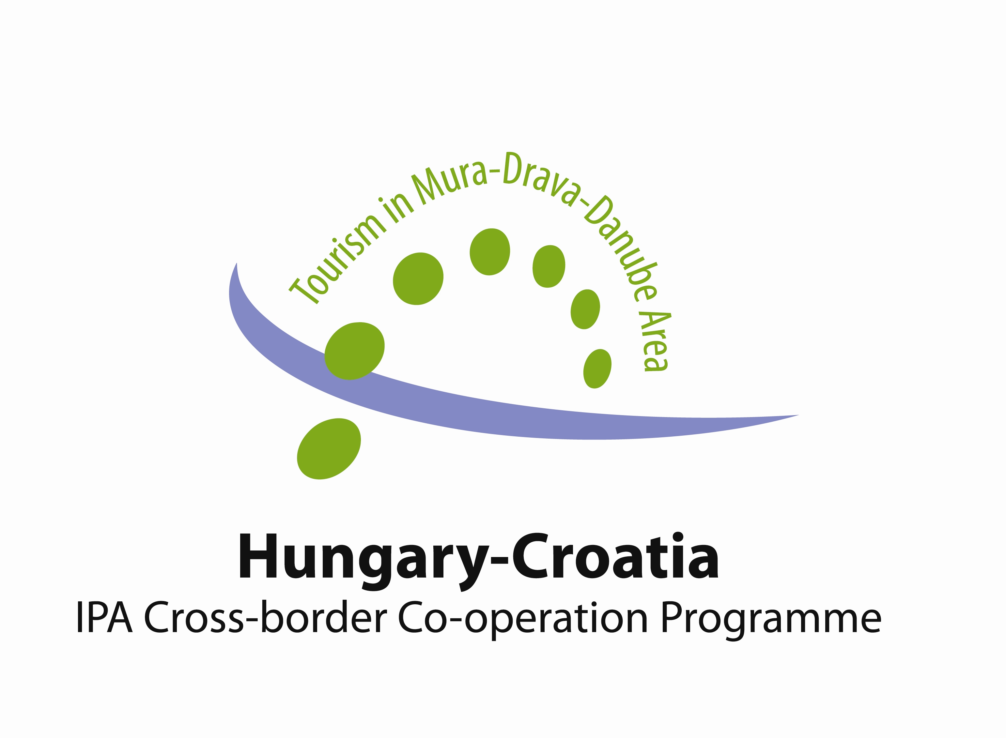

Report from study tour through Koprivnica-Križevci county and Varaždin county implemented within the IPA programme Hungary-Croatia 2007.-2013.
INVEST PRO project, contract number HUHR/1101/1.2.5/0003

Within the period from 28 to 29 September 2013 Križevci College of Agriculture organised a study tour for all partners participating in the project „INVEST-PRO”; Trade and industry chamber of Zala county as lead beneficiary, Trade and industry chamber of the Somogy county, Development agency of Varaždin county – AZRA, Križevci college of agriculture and entrepreneurs from the Zala and Somogy county, as well as from Varaždin and Koprivnica-Križevci county.
Based on the implemented study tour in Hungary in October and completed „Study on unused tourism potentials and investment possibilities in tourism in the Hungary-Croatia cross-border area”, organisers of the study tour in Croatia singled out those destination that will to the greatest extent introduce the participants with development potential of rural tourism and tourism in general, examples of best practice, as well as with tourism investments that were implemented or are currently in preparation phase in Koprivnica-Križevci and Varaždin county. Another objective of the study tour was to initiate creation of recognizable image of tourism destination of continental tourism of the aforementioned area, especially regarding future development and investment in existing or new forms of tourism offer. For that reason Croatian and Hungarian entrepreneurs were of special importance for this study tour, since the aforementioned study indicated that entrepreneurs express a high level of interest or advancing tourism development.

28. November 2013
The study tour started on Thursday, 28 November, 2013 at 9 o'clock with the meeting of participants at Križevci College of Agriculture (KCA) with the moto „Everything begins and ends with knowledge”. All present were greeted by College dean, Ms Marijana Ivanek-Martinčić, Ph.D who introduced them with the College history and some of its main activities. Ms Kristina Svržnjak, Ph.D presented the projects currently implemented by the College, with special emphasis on three projects in the field of tourism development in Koprivnica-Križevci county. Besides the INVEST-PRO project, the College also participates in the project „Helath&rural tourism DM model” whose final objective is to offer the College students optional module in the field of rural tourism, Ms Svržnjak also presented the „ECOTOP” project targeting development of the life long learning programme in the field of eco-tourism through e-learning. All the aforementioned indicates that the College has preconditions to offer in the future a whole new study programme under the title „rural tourism”. It was emphasized that the main recommendation of the completed evaluation study was that development of the cross-border area through tourism development should include the need of continuous education on advantages of life and work in the cross-border area by preserving and promoting specific characteristics of the tourism area in creatively designed tourism product. The organisers therefore decided that the study tour should start and end at KCA under the aforementioned moto „Everything begins and ends with knowledge”.
All present were greeted by the representative of the Tourism association of the Town of Križevci - Olinka Gjigaš, who presented results of previously implemented projects, as well as projects currently in progress and relating to development and investment in continental tourism in the Križevci area. It was pointed out that Križevci and its surroundings are a very attractive area with interesting natural, historical and cultural resources, with main resources lying in traditional vineyard cottages, vineyards and agricultural-food products. Križevci has a vista of eight church towers distributed at several town entries in the form of a cross, so the title of „The town with eight church towers" offers great predispositions for development of religious tourism. The most significant manifestations are The day of St Mark of Križevci and Križevačko veliko Spravišće. The participants were given brochures about the town of Križevci and the brochure „The heart of green Croatia" as the last project of Tourism association representing tourism offer of central Croatia, i.e. agrotourism, bike routes, hiking and riding paths, mountain homes, spas and health wellness, wine routes, events and manifestations related to tradition, history and old crafts, as well as rich and varying gastronomy offer.
The participants took a short tour of the most significant attractions for development of cultural and religious tourism:
- Gradska Munjara (the Town lighting house) – protected monument of industrial architecture as the first power plant that started its work in 1912, so people from Križevci can proudly boast that the first electric bulb was lit in their town not long after the first world light bulb was lit.
- Saint Cross Church – one of the oldest preserved buildings in the town and one of the oldest churches in continental part of Croatia. It is mentioned in written sources in 1232. One of many legends states that in the 6. century the newly settled Croats suffered from great thirst and whilst drinking water from the well positioned at the place of the church, they experienced the vision of the cross. The church disposes of a very valuable and significant marble altar, the piece made by Francesco Robbe 1756. Christ's body was sculpted out of one marble piece making it unique among old baroque works of art. Above the gothic triumphal arch there is a painting by Oton Iveković "Bloody assembly of Križevci", which took place in Križevci on 27. of February, 1397.
- Main square in Križevci – open town square hosting numerous events and activities, which was also the occasion for taking the first group photograph of all participants published in the local newspaper „Glas Podravine” (annex)
- Greek catholic cathedral – the most representative sacral building with valuable treasury and library with books dating from the 15. and 16. century.

Study tour participants headed towards the slopes of the Kalnik mountain, i.e. in the direction of Municipality of Kalnik and Kalnik settlement. In the centre of Kalnik there is Kalnik agricultural association in reconstruction and in its basement the company Kalničanka proizvodi d.o.o. was presented. Company director Martina Vidmanić presented the company as small company with 11 employees, developing its business activity based on its own production technology of producing autochthonous Kalnik cheese, whereas milk is bought solely from local milk producers from the pastures of the Kalnik hill of controlled quality. On this occasion cheese tasting event was organised and the participants could try six types of cheese: smoked Kalnik cheese, white Kalnik cheese, Kalnik cheese with peppers, Kalnik cheese with chives, Kalnik cheese with herbs and Kalnik prga (hard cheese with spices). All present agreed that the company Kalničaka represents a good example of sustainable business activity in small settlements and municipalities, where local entrepreneurship in the field of production of raw food material (milk) and increase of gastronomic offer through autochthonous products (cheese) is encouraged.
Unavoidable destination of the study tour was the peak of Kalnik, where Old town and Mountain home are located. Director of Tourism association of the municipality of Kalnik Krunoslav Đurec presented to the participants implemented and planned development tourism projects. He described the ruins of the Old town of Kalnik as the most significant tourism attraction relating to the story on Hungarian king Bela IV from the 13. century and the so called „Šljivari” (plum people). Fleeing before the Tatars, the king found a hiding place in the stone fortress of Great Kalnik. The Tatars surrounded the fortress for days in order to make the king and his army surrender due to hunger and exhaustion. However, people of Kalnik fed them with plums, and the Tatars failed to pursue their siege. Bela IV proclaimed people of Kalnik area nobles and envious town inhabitants of ridiculed them by calling the "the noble plum people". In honour of the above described legend each year Križevci hosts a famous manifestation called „Spravišće”.
After listening to the legend and enjoying the spectacular view of the surrounding villages, vineyards, orchards, fields and forests, the participants of the study tour headed towards Varaždin. Lunch was organised in Verglec restaurant, as the first restaurant with the licence of the Croatian autochthonous cuisine offering more than 70% of traditional recipes. The lunch was accompanied by the sound of the local organ-grinder, whom you can at all times meet in good mood and festive suit on streets and squares of the inner centre of Varaždin. Mr Josip Barulek, restaurant owner, presented the projects that are finalised, as well as those currently in preparation phase: construction of exclusive hotel in the centre of Varaždin, for which it is essential to obtain financial means from the EU funds.
Varaždin is called „baroque capital of Croatia” and it has protected baroque urban unit with rich monument and cultural heritage; 51 objects of monument heritage, palaces, villas, 500 years old city hall, the oldest music hall, churches and monasteries with rich collections, famous Varaždin cemetery..... In order for the study tour participants to become acquainted with a small part of the protected baroque urban unit, they took a tour of the inner centre:
- Stančić square providing the view of Varaždin feudal fortress (Old town), „Kula stražarnica” (guard tower) and „ Prassinsky – Sermage palace” hosting permanent exhibition of old and new masters, whereas on the front of the building there is a prominent balcony with the fence made of wrought iron.
- Statue of Grgur Ninski, bishop and great advocate of old Slavic language and national script. This is the work of the famous sculptor Ivan Meštrović, and one legend states that touching the statue with your thumb brings good luck.
- In Herzer palace you can see an entomological collection „Amazing world of bugs” consisting of several thousands of various insects, which professor nob. Košćec mounted with miniature tools he invented himself.
- Anđelinjak (angel garden) as „the world as it used to be and no longer is”, i.e. „the place where you can meet your guardian angel again”.

After Varaždin the participants headed towards Đurđevac where they were accommodated in Picok hotel and had dinner accompanied by musical programme typical of Đurđevac area.

29 November 2013
The next day started at 9 o'clock with the lecture on connection between Picok hotel, cultural tourism and Association of wine producers of Đurđevac region, as well as their role for development of rural tourism in this part of the county. Representatives of Picok hotel, Tourism association of the Town of Đurđevac and representatives of wine producers emphasized the potentials of development of eco-tourism with reference to Đurđevački peski (Đurđevac desert) as protected botanical area with a large number of endemic species, unique flora and fauna with over 300 butterfly species. Besides endemic species, one can also see the remains of sand dunes thus justifying the title „Croatian Sahara”.
The participants afterwards went to the old town of Đurđevac where they are acquainted not only with the offer of cultural tourism based on the Picok legend, but also with the other tourism offer of Đurđevac including permanent exhibition of artistic collection of Ivan Lacković Croat, and other occasional exhibitions which are continuously organised in gallery facilities of the Old town. It needs to be emphasized that principle development of tourism in Đurđevac is based on "Picoki legend" and traditional cultural-tourism manifestation „Picokijada” as memory of legendary defence of Đurđevac people from the Turks. The legend says that whilst invading the Old town the Turks encountered unexpected resistance and therefore decided to pursue the siege in order to starve the army and people who took refuge in the fortress of Đurđevac. However, the food was indeed scarce with merely one small rooster left, which was placed in the cannon and fired on the Turkish military camp. Thinking that there is plenty of food in the fortress since it can be wasted like that, the Turks gave up on their invasion of the Old town.
The visit to the Old town of Đurđevac was followed by the trip to Hlebine and visit to the Naive art gallery, where tourism potential of Municipality of Hlebine was presented from the aspect of development of cultural tourism and tradition of naive art. Naive art is the name for paintings made by self-taught artists. Hlebine painting school was of crucial importance for the affirmation of naive art in Croatia, when Krsto Hegedušić together with the villagers Ivan Generalić and Franjo Mraz in 1930 started to intensively paint with the technique of oil on glass, which brought them world fame. After World war II Ivan Generalić became the central figure of Hlebine school and teaches the majority representatives from the second generation amongst whom we can single out Mijo Kovačić, Ivan Večenaj, Ivan Lacković Croata, Dragan Gaži, Franjo Filipović and Martin Mehkek. Their pieces emphasize romantic concept of Podravina landscape and lyric idealisation of rural life.
The participants subsequently headed to tourism family agricultural farm Rakić, where they were served autochthonous products of Podravina and Prigorje region. The owner and his family presented the farm, tourism offer and directions of development of rural tourism through examples of synergies with the local farmers in the context of offering traditional home made products originating from this area. this family farm is located close to Križevci and merely 500 metres away from the Čabraji lake. It offers solely home-made specialties and wine in very agreeable ambience offering organisations of celebrations for larger groups of visitors, with spacious terrace and large field with equipped for children. Furthermore, the Rakić family restored an old archaic house (three rooms and two apartments for accommodation) and furnished it with authentic objects and furniture. Romantic forest hiking path is close at hand, and the family owns two horses with possibility to arrange sightseeing on the horse.
The study tour was concluded with return to Križevci college of agriculture and the participants expressed their content with organisation of the tour and useful business contacts they made on the way.
With reference to the aforementioned, both Croatian and Hungarian entrepreneurs were asked three questions and their answers are listed below:

- What did you like the most within the study tour of INVEST-PRO project?
- Socialising, learning about tourism capacities I was not aware of, gastro offer
- I liked the stay at Picok hotel the most, as well as visiting the rural tourism facility at Čabraji lake.
- I liked taking the tour of the rural part of Koprivnica-Križevci county, learning about history and traditions of the county, as well as the work of project partners on networking between profession, knowledge and entrepreneurs.
- Gastronomy offer.
- Besides study tour to Croatia, I would like to point out that I also liked the study tour to Hungary where we saw possibilities of development of rural tourism first hand. I liked the visit to agricultural family farms whose main business activity is rural tourism, especially means of income and methods of attracting tourists with contents that are very interesting and applicable in our surroundings.
- Very pleasant and interesting study tour, nice atmosphere, varying and interesting activities. Exceptionally good organisation from the very beginning, when we were warmly greeted and better acquainted with the project. What I liked best was sightseeing in Varaždin and the Old town of Đurđevac.
- Study tour was exceptionally well organised, regarding both its duration and content. The participants were able to get to know the entire region and get acquainted with the offer of north-west Croatia. This study tour could serve as example for owners of tourism agencies who could offer such tourism events. All participants can find a joint interest for future cooperation. I was impressed by kindness and courtesy of the owners of tourism facilities. I regret that we lacked time to visit Varaždin cemetery and some wine producers on wine road of Đurđevac.
- We have visited a really beautiful neighbourhood, I would not thought, that besides the seaside this country has an other area that has a touristic significance.
- The cheese factory and the winery, as well as the model farm were the most interesting ones for me.
- I liked the programs, the sightseeing tours, the orchestra, and the room looked fantastically.

- What did you find most useful for your business activity? (or future business activity)..
- Vision of merging to small associations (example of Kalnik)
- The most useful for me was presenting of business activity of business subjects we visited. I primarily refer to Verglec restaurant and family farm Rakić we visited.
- I think I will find the acquaintances I made within this tour useful in the future.
- Examples of best practice through stories of successful business activity, development of tourism offer, future plans and projects.
- I got numerous ideas for future development of my trade, but only for one segment of my business activity which I will develop in the period from 2016 onwards.
- What I would find most beneficial for the future is tasting of autochthonous Varaždin dishes and Kalnik cheeses.
- I knew the fact that the entrepreneurial collaboration is essential for the region to acquire better reputation. The common brand is a good solution, but only if the members represent equal quality.
- The local products, the smart building upon on the legends, collaboration
- For my enterprise, I consider important the established contacts and the gained experiences.

- Which partner from the project would you like to collaborate with in the future?
- It is a difficult question, since the colleagues come from different business sectors, but I would definitively like to cooperate with some of the colleagues.
- I would like to cooperate with the owners of restaurants and family farms whose main business activity is rural tourism, especially regarding distribution of my products (teas) which could be included in their offer for tourists. However, according to my experience the greatest problem are administrative obstacles between the two countries regarding registration of food supplements or food.
- Cooperation with all partners because I liked them all.
- With the owner of Verglec restaurant from Varaždin.
- Unfortunately, I can not cooperate with anybody because of the distance. But the ars poetica of the cheese factory- and the co-operative where it belongs- as well as the model farm had a great effect on me.
- My enterprise is locally restricted to Zala county, so I primarily would like to cooperate with enterprises from Zala county which I got to know in the framework of the project. However, I also consider the cross border contacts important for the future.

